**EPA.GOV**

What does your usage mean? The average American uses around 82 gallons per day per person in the household. That means a family of four would use around 10,000 gallons in a 30-day period. But usage varies a great deal across the country, mostly because of differences in weather patterns. For example, water use tends to be higher in drier areas of the country that rely more on irrigation for outdoor watering than in wetter parts of the country that can rely on more rainfall.

Based on information from Water Research Foundation, “Residential End Uses of Water, Version 2.” 2016; and The US Geological Survey, “[Estimated Water Use in the United States.” 2015](https://www.usgs.gov/mission-areas/water-resources/science/water-use-united-states).

**How are you being charged?**

Water utilities need to charge customers to build and maintain infrastructure—the water storage tanks, treatment plants, and underground pipes that deliver water to homes and businesses. The revenue is also used to pay the workers who provide you with water service day or night. There are a wide variety of rate structures that are used to bill customers, some of which are described below.

**Rate Types**

Flat Fee is a rate structure where all customers are charged the same fee, regardless of the amount of water used. Flat fees are the simplest type of rate structure and are rarely used today. They generally don’t provide revenue sufficient to operate the utility and are not good at promoting water efficiency.

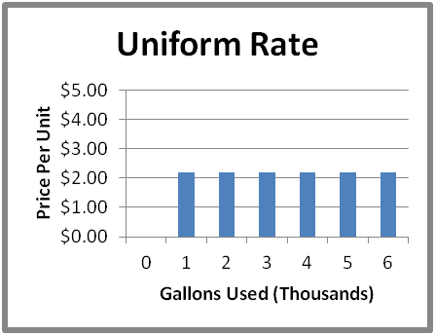**Uniform Rate** is a structure that has a constant per unit price for all metered units of water consumed on a year-round basis. It differs from a flat fee in that it requires metered service. Some utilities charge varying user groups different rates such as charging residential households one rate and industrial users a different rate. Constant block rates provide some stability for utilities and encourage conservation because the consumer bill varies with water usage.

**Increasing Block Rates** is a rate structure in which the unit price of each succeeding 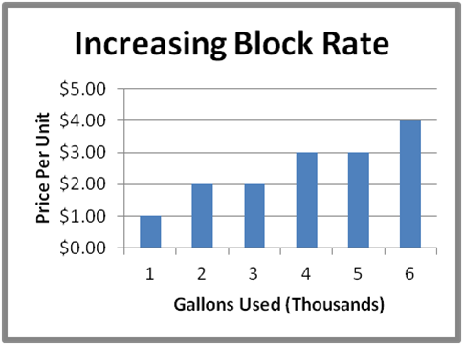block of usage is charged at a higher unit rate than the previous block(s). Increasing block rates are designed to promote conservation and are most often found in urban areas and areas with limited water supplies. The graphic to the right is an example of an increasing block rate structure.

**Declining Block Rates** are the opposite of increasing block rates where the unit price 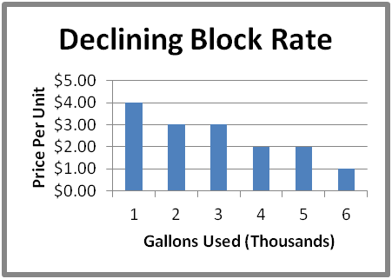of each succeeding block of usage is charged at a lower unit rate than the previous block(s). These rate structures are popular in rural areas that service large farming populations or areas with large users such as heavy industry and where water is plentiful.

**What are my charges going towards?**

Many utilities use a combination of a fixed fee (base) and a variable fee (volume) for their water rate structure. Fixed charges generally include the price the customer pays as a base charge to help cover costs for maintaining existing infrastructure and repaying loans and bonds used to build that infrastructure. Variable charges are the price the customer pays per volume of water used, which reflect the costs of providing water, such as costs for chemical treatment to provide safe water and energy to move and deliver water.

Most utilities will provide you with a breakdown of charges in your "billing detail" or "summary of charges" section. Note that some utilities measure both water entering the house and waste leaving to the sewer, but many utilities have only one meter on location and will charge both volumes based on water entering the house. This is yet another reason to reduce your own water use.

**Communities Face Challenges to Meet Demand**

Managing water is a growing concern in the US. Communities across the country are starting to face challenges regarding water supply and a need to update aging water treatment and delivery systems, sometimes referred to as "water infrastructure.” Many of the states that have projected population growth increases also have higher per capita water use and can expect increased competition for water resources.  Forty states told the Government Accountability Office in a 2014 [report](http://www.gao.gov/assets/670/663344.pdf)  that they expected to have water shortages over the next ten years that were not related to drought.

Strains on water supplies and our aging water treatment systems can lead to a variety of consequences for communities, such as:

* Higher water prices to ensure continued access to a reliable and safe supply.
* Increased summer watering restrictions to manage shortages.
* Seasonal loss of recreational areas like lakes and rivers when the human demand for water conflicts with environmental needs
* Expensive water treatment projects to transport and store freshwater when local demand overcomes available capacity.

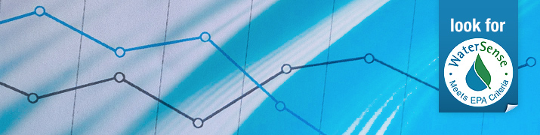**Statistics and Facts**

**Related Information**

* [About WaterSense](https://www.epa.gov/watersense/about-watersense)
* [Ways to Start Saving Water](https://www.epa.gov/watersense/start-saving)
* [WaterSense Labeled Products](https://www.epa.gov/watersense/watersense-products)
* [Fact Sheets](https://www.epa.gov/watersense/learn-more)

**Why Save Water?**

* According to a [2014 Government Accountability Report](http://www.gao.gov/products/GAO-14-430), 40 out of 50 state water managers expect water shortages under average conditions in some portion of their states over the next decade.
* Each American uses an average of 82 gallons of water a day at home (USGS, Estimated Use of Water in the United States in 2015).
* We can all use at least 20 percent less water by installing water-efficient fixtures and appliances.
* The average family spends more than $1,000 per year in water costs, but can save more than $380 annually from retrofitting with WaterSense labeled fixtures and ENERGY STAR certified appliances.

**WaterSense & Water Savings**

* WaterSense labels products that are 20 percent more water-efficient and perform as well as or better than standard models.
* The average family can save 13,000 gallons of water and $130 in water costs per year by replacing all old, inefficient toilets in their home with WaterSense labeled models.
* Replacing old, inefficient bathroom faucets and aerators with WaterSense labeled models can save the average family $250 in water and electricity costs over the faucets' lifetime.
* Replacing showerheads with WaterSense labeled models can reduce the average family's water and electricity costs by $70 and can save the average family more than 2,700 gallons of water per year, equal to the amount of water needed to wash 88 loads of laundry.
* Giving a home's main bathroom a high-efficiency makeover by installing a WaterSense labeled toilet, showerhead, and faucet aerator can pay for itself in as little as 1 year.
* Replacing a clock-based controller with a WaterSense labeled irrigation controller can reduce an average home's irrigation water use by up to 30 percent and can save an average home up to 15,000 gallons of water annually.

**Water Stats**

* The average family can waste 180 gallons per week, or 9,400 gallons of water annually, from household leaks. That's equivalent to the amount of water needed to wash more than 300 loads of laundry.
* Household leaks can waste approximately nearly 900 billion gallons of water annually nationwide. That's equal to the annual household water use of nearly 11 million homes.
* Running the dishwasher only when it's full can eliminate one load of dishes per week and save the average family nearly 320 gallons of water annually.
* Turning off the tap while brushing your teeth can save 8 gallons of water per day and, while shaving, can save 10 gallons of water per shave. Assuming you brush your teeth twice daily and shave 5 times per week, you could save nearly 5,700 gallons per year.
* Letting your faucet run for five minutes while washing dishes can waste 10 gallons of water and uses enough energy to power a 60-watt light bulb for 18 hours.
* Outdoor water use accounts for more than 30 percent of total household water use, on average, but can be as much as 60 percent of total household water use in arid regions.
* If the average sized lawn in the United States is watered for 20 minutes every day for 7 days, it’s like running the shower constantly for 4 days or taking more than 800 showers. That's equivalent to the amount of water needed for the average family to take 1 year's worth of showers.
* As much as 50 percent of the water we use outdoors is lost due to wind, evaporation, and runoff caused by inefficient irrigation methods and systems. A household with an automatic landscape irrigation system that isn't properly maintained and operated can waste up to 25,000 gallons of water annually.
* When hiring a professional to install or audit your landscape irrigation system, be sure he or she is certified by a WaterSense labeled irrigation program. If the system is well managed, a household's irrigation water use can be reduced by 15 percent, or nearly 7,600 gallons of water, annually. That's the amount of water needed to take 480 showers.

* Other data and information used by WaterSense is [available](https://www.epa.gov/watersense/data-and-information-used-watersense). Please contact the WaterSense Helpline at [watersense@epa.gov](mailto:watersense@epa.gov) or (866) WTR-SENS (987-7367) if you are interested in learning the sources for these statistics and facts.

https://www.epa.gov/watersense/statistics-and-facts